Report on Lakshya
On the occasion of diamond jubilee year of Government college of Engineering, Aurangabad, a state level badminton and chess championship was organized by college on 11 and 12th January 2020. This championship was only for Government and Government aided colleges of Maharashtra only. Accommodation and food was inclusive in entry fees.
Inauguration was on 10:30 am on 11th of January. Chief Guest of the event was International Master Sakshi Chitlange. She is an International Master in chess and Shivchhatrapatai Awardee. At 11:30 am, there was simultaneous exhibition chess match where IM played against 16 participants simultaneously.
We would like to thank Dr. P B Murnal sir, Dr. U J Kahalekar sir and Dr. S A Patil sir for their support and coordination for the event.

CHESS:
49 players from 6 colleges had participated in that event. Senior national arbiter Pushkar Dongre and senior national arbiter Hemant Late were the arbiters for this event. Tournament was according to swiss system and fide laws.
What is the Swiss System?
In a Swiss-system chess tournament, organizers try to give each player a similar number of White and Black games by the end of the event. Organizers rank players in each group according to a rating system where players are separated into a top and bottom half. Players in the top half of each group are then paired with those the bottom half. For instance, if there are six players in the top-scoring group, player No. 1 will play against player No. 4, player No. 2 will be pitted against player No. 5 and player No. 3 will face off against player No. 6. This system is technically known as the "Dutch system," according to FIDE, the international chess federation. But this pairing method is still considered part of the Swiss system and is the most common form of pairing in Swiss tournament

Day 1:
Starting rank was published on the basis of average team rating. As there were 11 teams form 6 colleges, there were 4 swiss rounds.
Three of the four rounds were completed on day 1.
Schedule
10:30 | Inauguration
11:30 | Simultaneous Exhibition
1:00 – 2:00 | Lunch
3:00 – 4:00 | First round
4:00 – 5:00 | Second round
5:00 – 6:00 | Third round

Day 2:
9:00 – 10:00 | Breakfast
11:00 – 12:30 | Fourth round
1:00 | Display of final standings

Prize distribution:
Prize distribution was held on 4:00 pm of 12th of January 2020.
Results:
Winner: COEP-A
Runner Up: GECA-A

Final Standings:
BADMINTON:
Girls teams:
Govt. Nagpur
GECA-1
GECA-2
SGGS
COEP

Boys teams:
Govt. Jalgaon
COEP-1
Govt. Pharmacy, Aurangabad-1
Govt. Karad
Govt. Avsari
Govt. Yavatmal
GECA-1
SGGS
COEP-2
Govt. Pharmacy, Aurangabad-2
GECA-2
GECA-3

Matches were conducted on knockout basis.

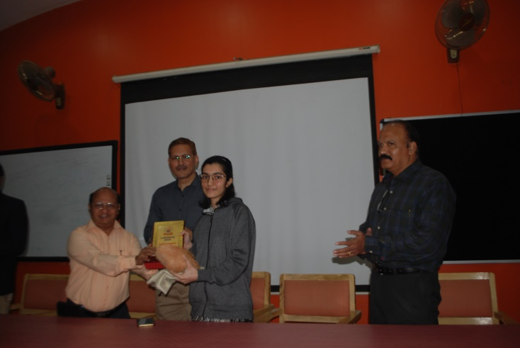
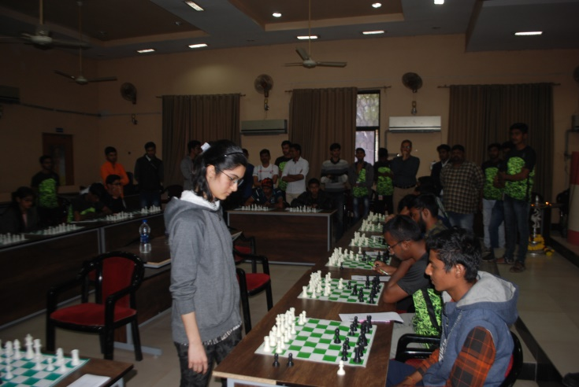

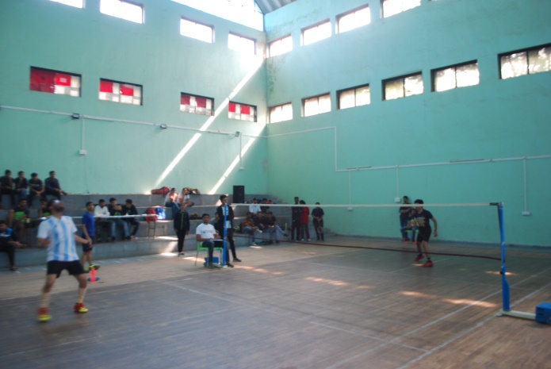
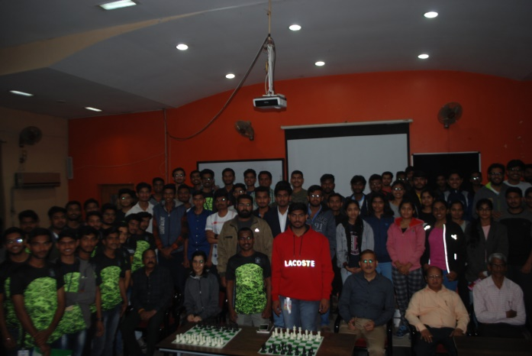

Results:
Winner(B): COEP-A
Runner Up(B): GECA-A

Winner (G) : Nagpur
Runner up(G) : COEP

EVENT TEAM:

1 | PRAVIN GAJMAL | SPORTS SCRETARY
2 | AJAY SHEP | EVENT HEAD
3 | PRAMOD DURBE | BADMINTON HEAD COORDINATOR
4 | HARIDAS BHUJANG | CHESS HEAD COORDINATOR

